Dashboard Gadgets

Introduction
JIRA can produce mini charts and reports for display on a user/project's dashboard (AKA home screen). The various charts and reports are generated by 'Gadgets'.

Creating a personal dashboard
In the example below a new dashboard is created and a gadget that lists the number of samples in each state is added.
Under the 'Dashboard' drop down select 'Manage Dashboards' to bring up the Manage Dashboards page (Illustration 1: The 'Dashboards' drop-down menu).
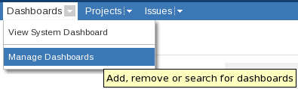
Illustration 1: The 'Dashboards' drop-down menu
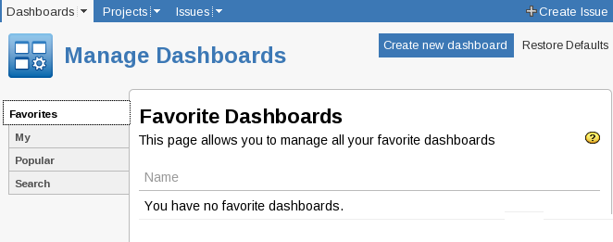
Illustration 2: The 'Manage Dashboards' page
On the Manage Dashboards page select the 'Create new Dashboard' link near the upper left. This will open a page containing a form (Illustration 3: The 'Create New Dashboard' page).

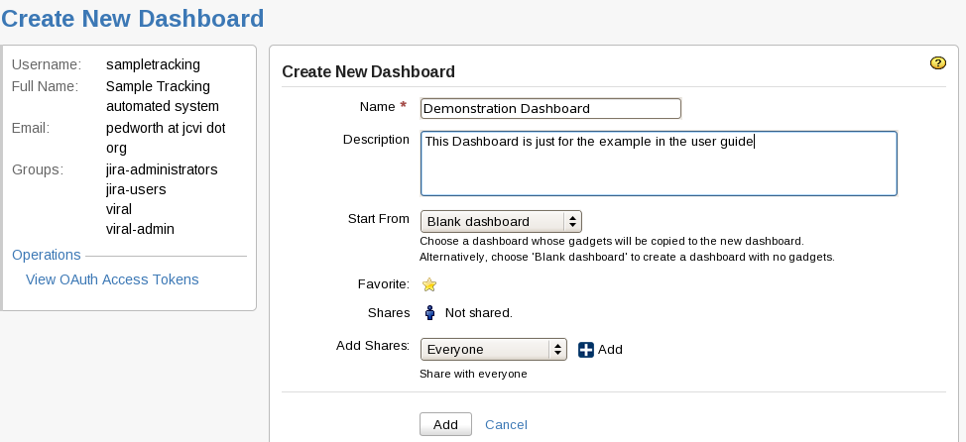
Illustration 3: The 'Create New Dashboard' page
The only required field for creating as dashboard is name, all the others can be ignored. Clicking 'Add' will return the user to the Manage Dashboards page. Select 'My' from the tabs down the left side of the screen (Illustration 4: The 'Manage Dashboards' page – with the newly created dashboard). The newly created dashboard can be accessed via its entry on this page or via the Dashboards drop-down menu (Illustration 5: The newly created dashboard in the 'Dashboards' drop-down menu).
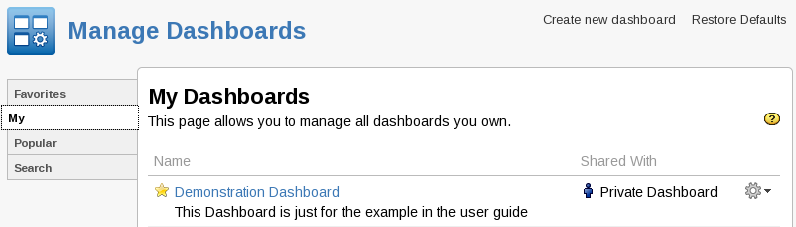
Illustration 4: The 'Manage Dashboards' page – with the newly created dashboard
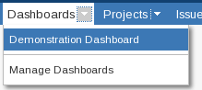
Illustration 5: The newly created dashboard in the 'Dashboards' drop-down menu
The dashboard will initially contain only two dashed areas with 'Drag your gadgets here' and 'Add a New gadget' written in them (Illustration 6: The newly created dashboard). At the top there are three icons, 'Add Gadget', 'Edit Layout' and 'Tools'.
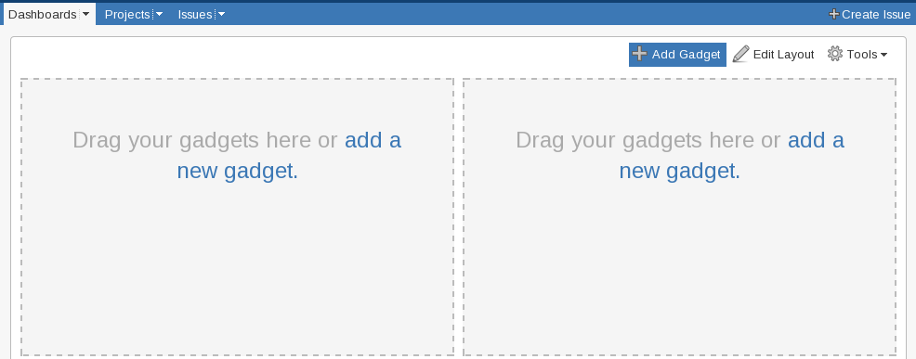
Illustration 6: The newly created dashboard

Adding a Gadget
Clicking the 'Add Gadget' Icon, or the links in the dashed boxes, brings up the Gadgets Directory pop-up (Illustration 7: The 'Gadget Directory'). There are a confusing number of gadgets to choose between. Enter 'issue statistics' in the search box to find the gadget needed (Illustration 8: The 'Issue Statistics' Gadget).
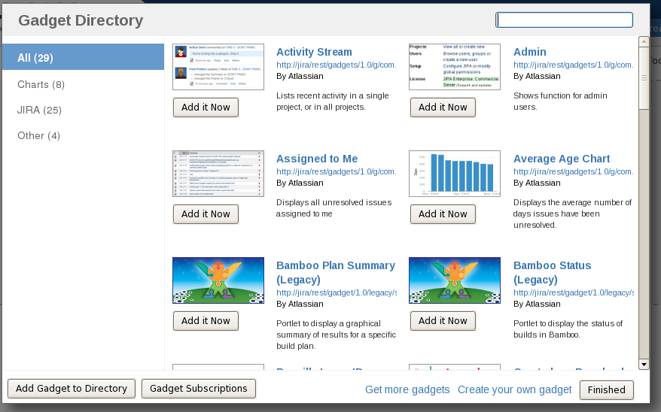
Illustration 7: The 'Gadget Directory'
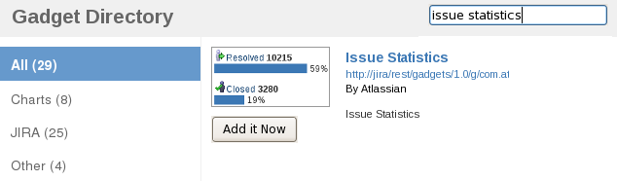
Illustration 8: The 'Issue Statistics' Gadget
Click the 'Add it Now' button and then 'Finished'.
One of the dashed boxes should have been replaced with a form titled 'Issue Statistics'.
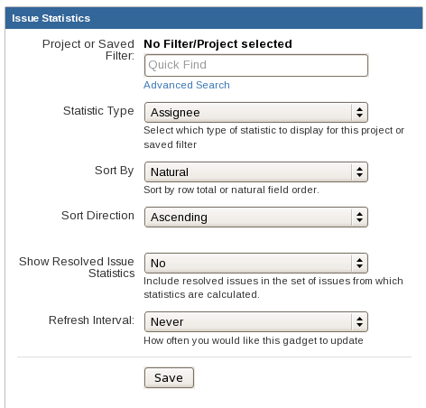
Illustration 9: The 'Gadget Directory'
The fields of the form should be set to:
Project or Saved Filter
Enter the name of the project or filter if known. Otherwise click 'Advanced Search' which opens up a window very similar to that used for generating reports.
Statistic Type Assignee
Sort By Natural / Total
Sort Direction Assending/Decending
Show Resolved ... Yes/No
Refresh Interval Never/15min/30min/1hr/2hr
And click 'Save'
The new gadget will appear where the form was on the Desktop (Illustration 10: The new 'Gadget').
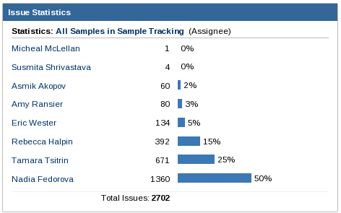
Illustration 10: The new 'Gadget'

